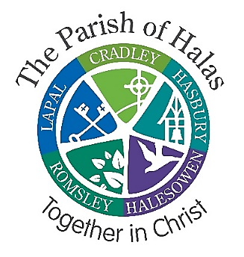

Application Form
Children and Family Worker

Name

Address

Email

Telephone/Mobile

Length of notice of current post

Are you a member of any organisation whose constitution, polices, objective or public statements are incompatible with the teaching of the Church of England in relation to the equality of persons or groups of different races?
Yes No

Do you currently have the right to work in the UK without any additional approvals?
Yes No

Employment
Please can you provide details of paid employment that you have since leaving school including dates (most recent first):

Education and qualifications
Please give brief details of your education, from high school onwards including any courses or qualifications that you consider relevant for this post:

Personal qualities and professional experience
We would like to know more about who you are.
Using the person specification, please explain how your knowledge, skills, abilities and personal qualities demonstrate your suitability for this role:

We would like to know more about your professional experience.
Please explain how your career/experience to date equips you with the experience of transferrable skills to fulfil this role:
Declaration
I confirm that all the information given in this form is correct and that I have not omitted anything which might disqualify me from holding this post. I understand that the data given will be processed by the Halas Parish Steering group and all details stated will be subject to our confidentiality policy, for the purposes of recruitment only.

Signature
Date

Referees
Please supply the names, telephone numbers, emails of two referees. These must cover the last 2 years as a minimum so please provide a third referee if applicable. If you are currently employed, one of your referees must be your employer.
Referee 1

Referee 2

Referee 3 if applicable

Due to the occupational requirement of the post holder to be a practising Christian, lay or ordained, and an active communicant member in good standing within the Church of England or of a Church which is in communion with the Church of England, or a Church that is a member of the Churches Together in Britain and Ireland, Churches Together in England or the Evangelical Alliance, please supply a referee to establish such “good standing” which will be taken up prior to consideration of invitation to interview. This referee could be the same or additional to the other two referees requested. For those who are ordained or hold a bishop’s licence in the Anglican Church it must be their current diocesan or area bishop.

May we contact these referees before the interview?
Yes No

This role requires you to travel around the Parish.
Do you possess a current driver's license?
Yes No

Do you have or intend to obtain a vehicle, which would be used for official travel when necessary? (mileage would be payable)
Yes No

If not, can you confirm you are able to travel by other means?
Yes No

Details

